Cloud Watch_SNS_Cloud trail
1.Enable CloudTrail monitoring and store the events in S3 and CloudWatch log events.
- Process of CloudTrail Created
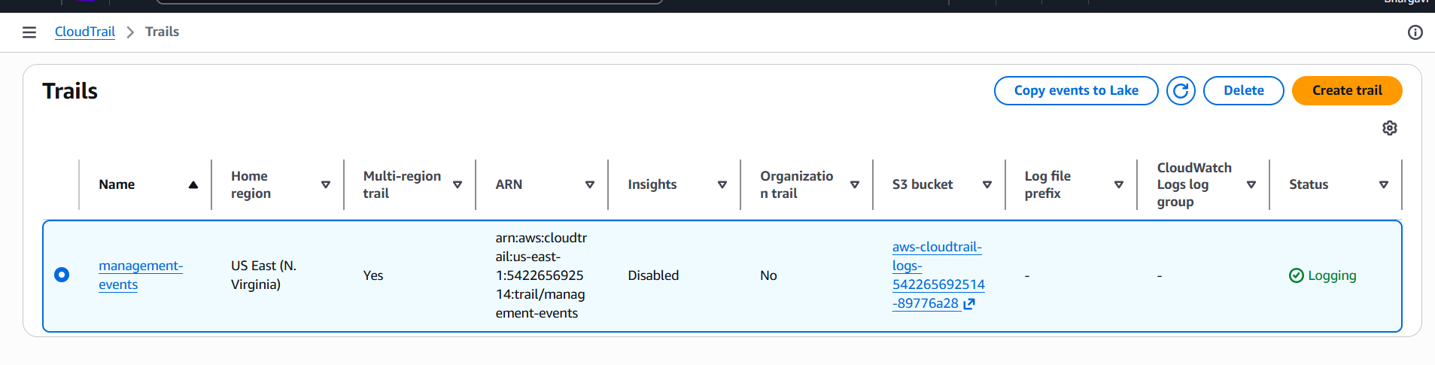
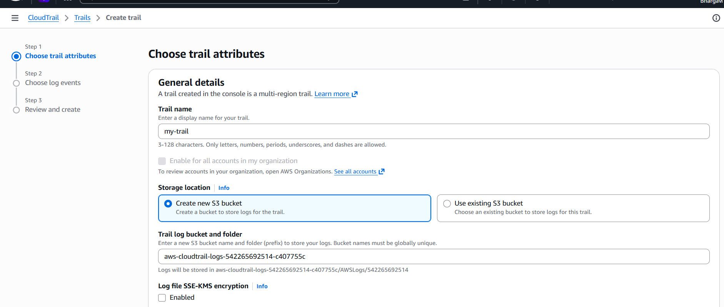
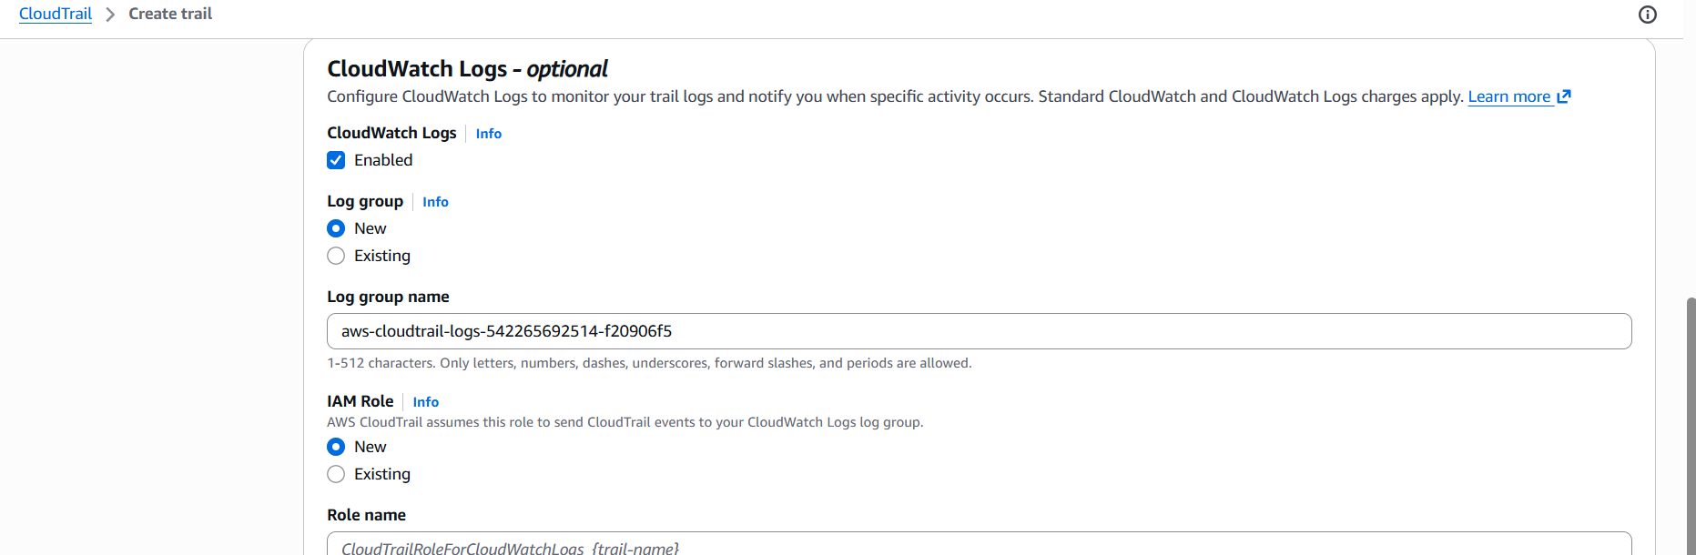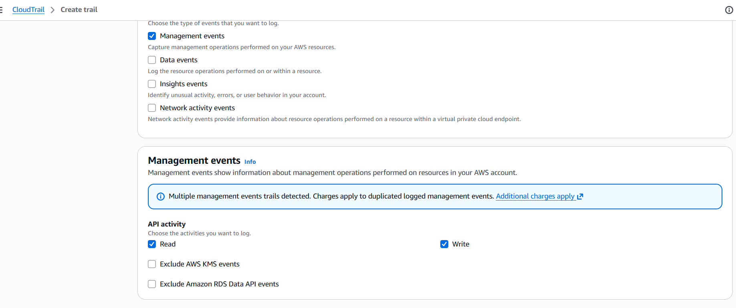
- We can logs in S3 bucket
- Cloud trail created successfully
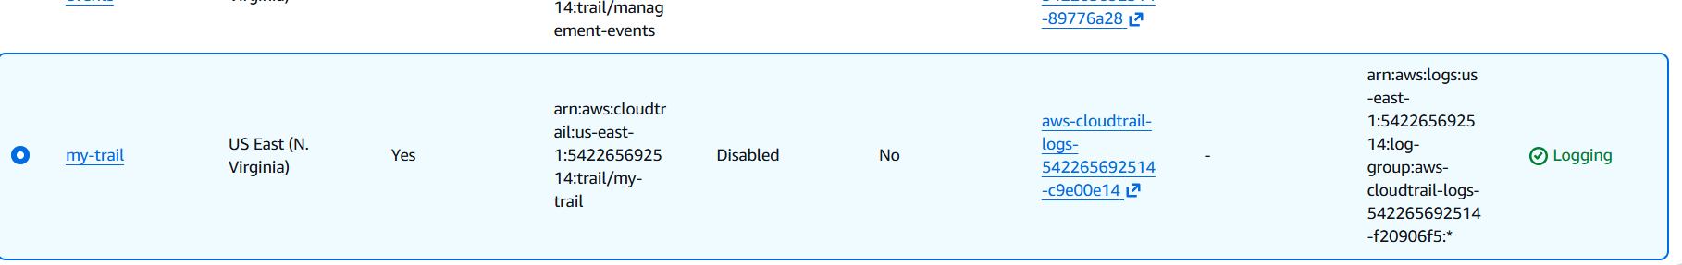
- We can check logs in cloud watch log group log steams
- Go to Cloudtrial click on create Trial choose existing s3 bucket browse your s3
- bucket click log file validation as enabled Disable Log file SSE-KMS encryption
Enable Management events Click on create
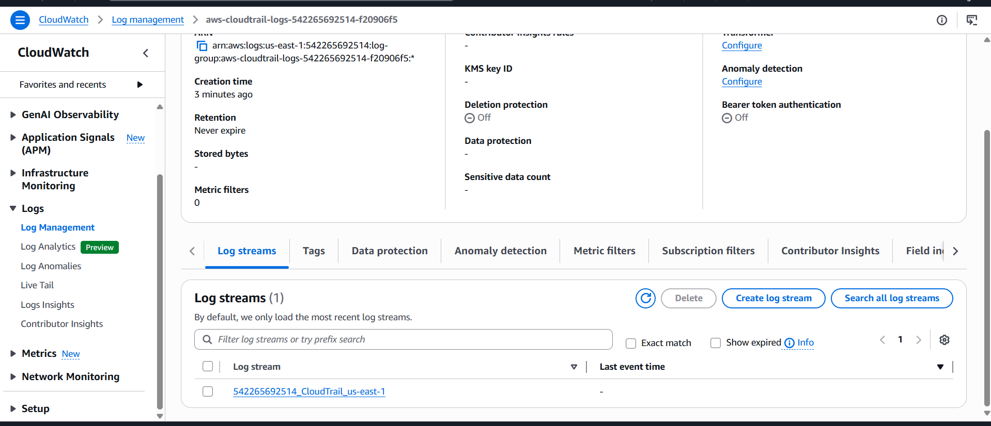
- See these are cloudwatch log events.
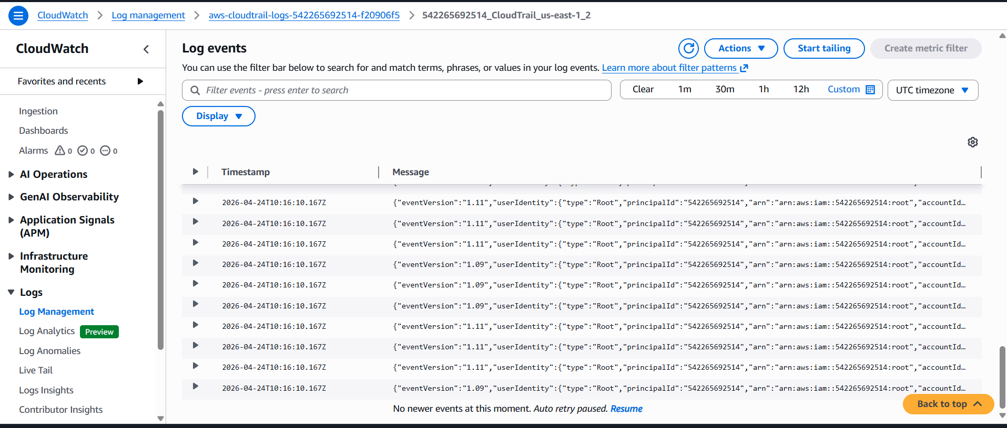
2.Enable SNS for CloudTrail to send alerts via email.
- Creation of SNS messages.
- Send the confirmation mail to your gmail.
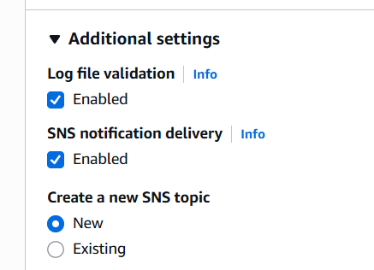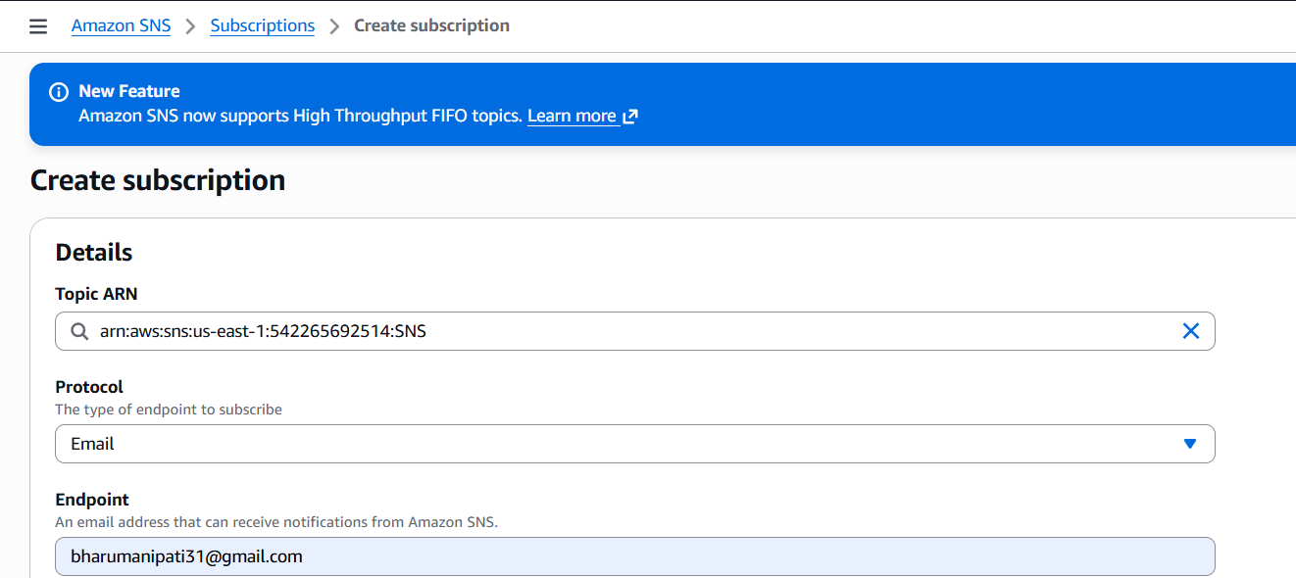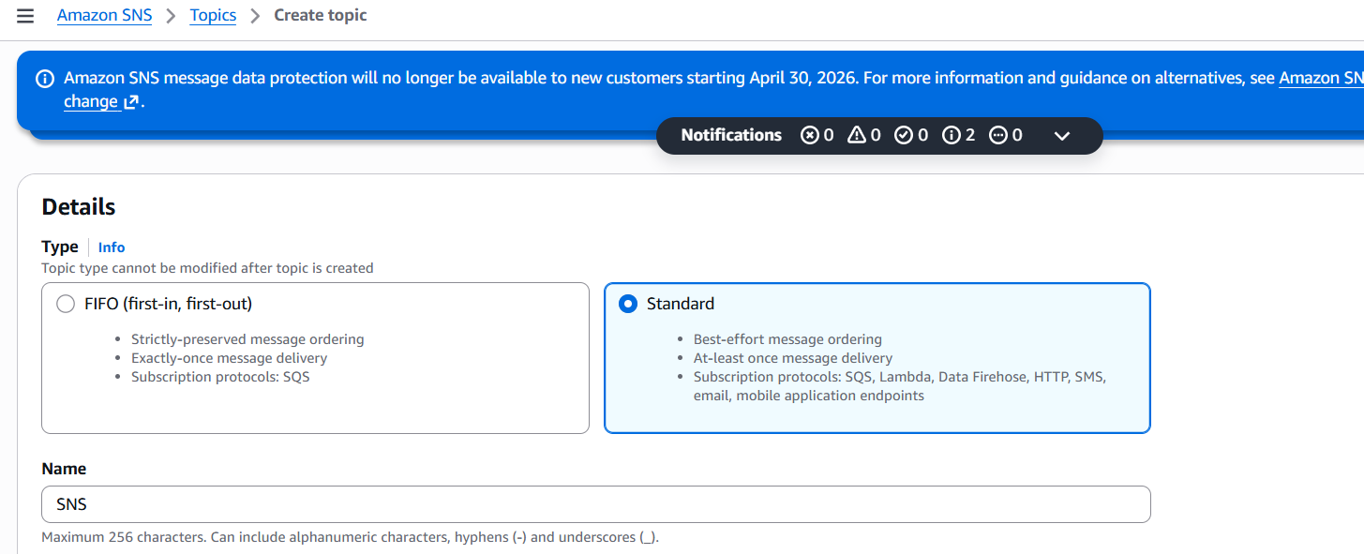
- Created Protocol Email in SNS
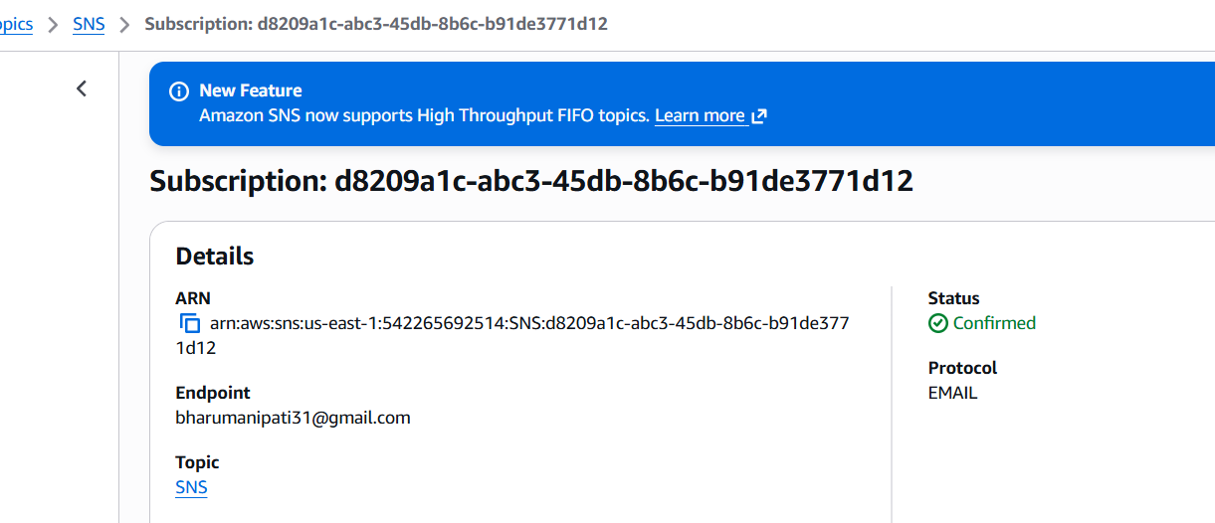
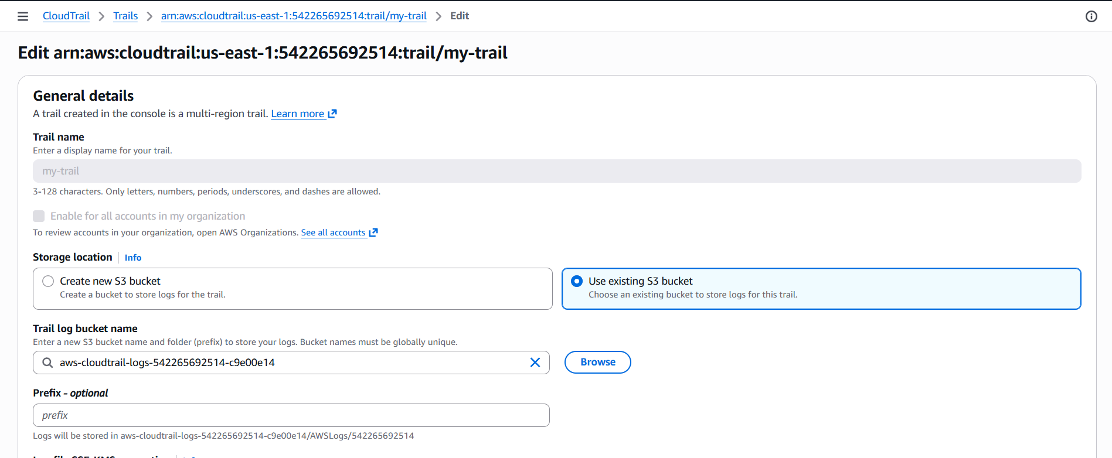
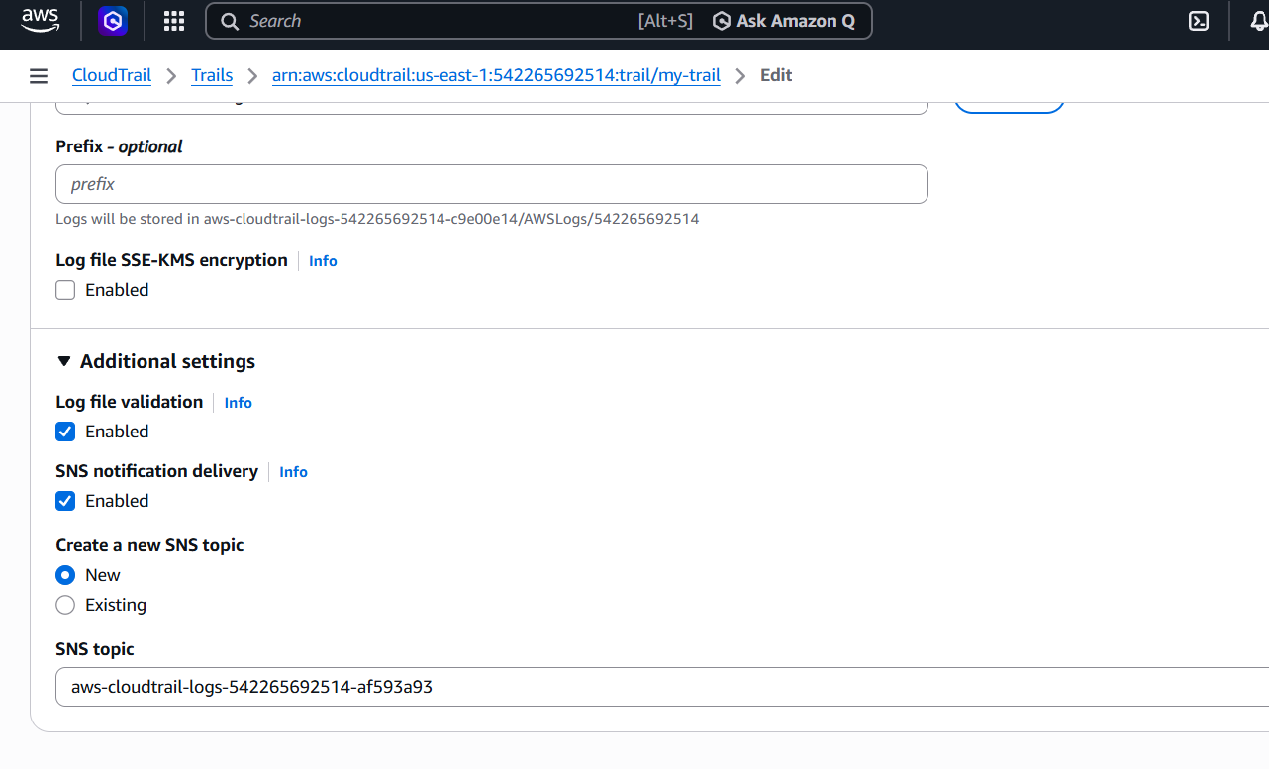
- Acceptance the subscription Create a metric in the cloudwatch
- ● Create alarm for that metric
- ● Open mail and check the alert
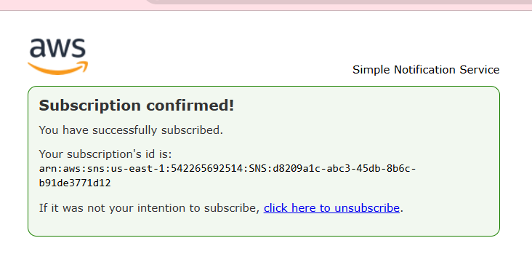
3.Configure CloudWatch monitoring and record the CPU utilization and other metrics of EC2.
- Select the Ec2 instanceClick to instance setting — troubleshoot —- detailed monitoring : enable it.
See the metrics of the instance here we can see the detailed monitor
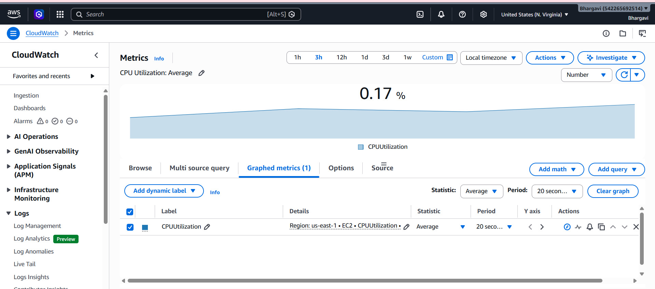
4.Create one alarm to send an alert to email if the CPU utilization is more than 70 percent.
RUN any Ec2 instance in AWS and Connect with pem in gitbashcreate an alert message in alarm the and set more than 70 CPU utilizationsee the cpu utilization with top command if it is 0use this yes >/dev/null for cpu high ratecheck the cpu utilization again we get the high cpu utilization.
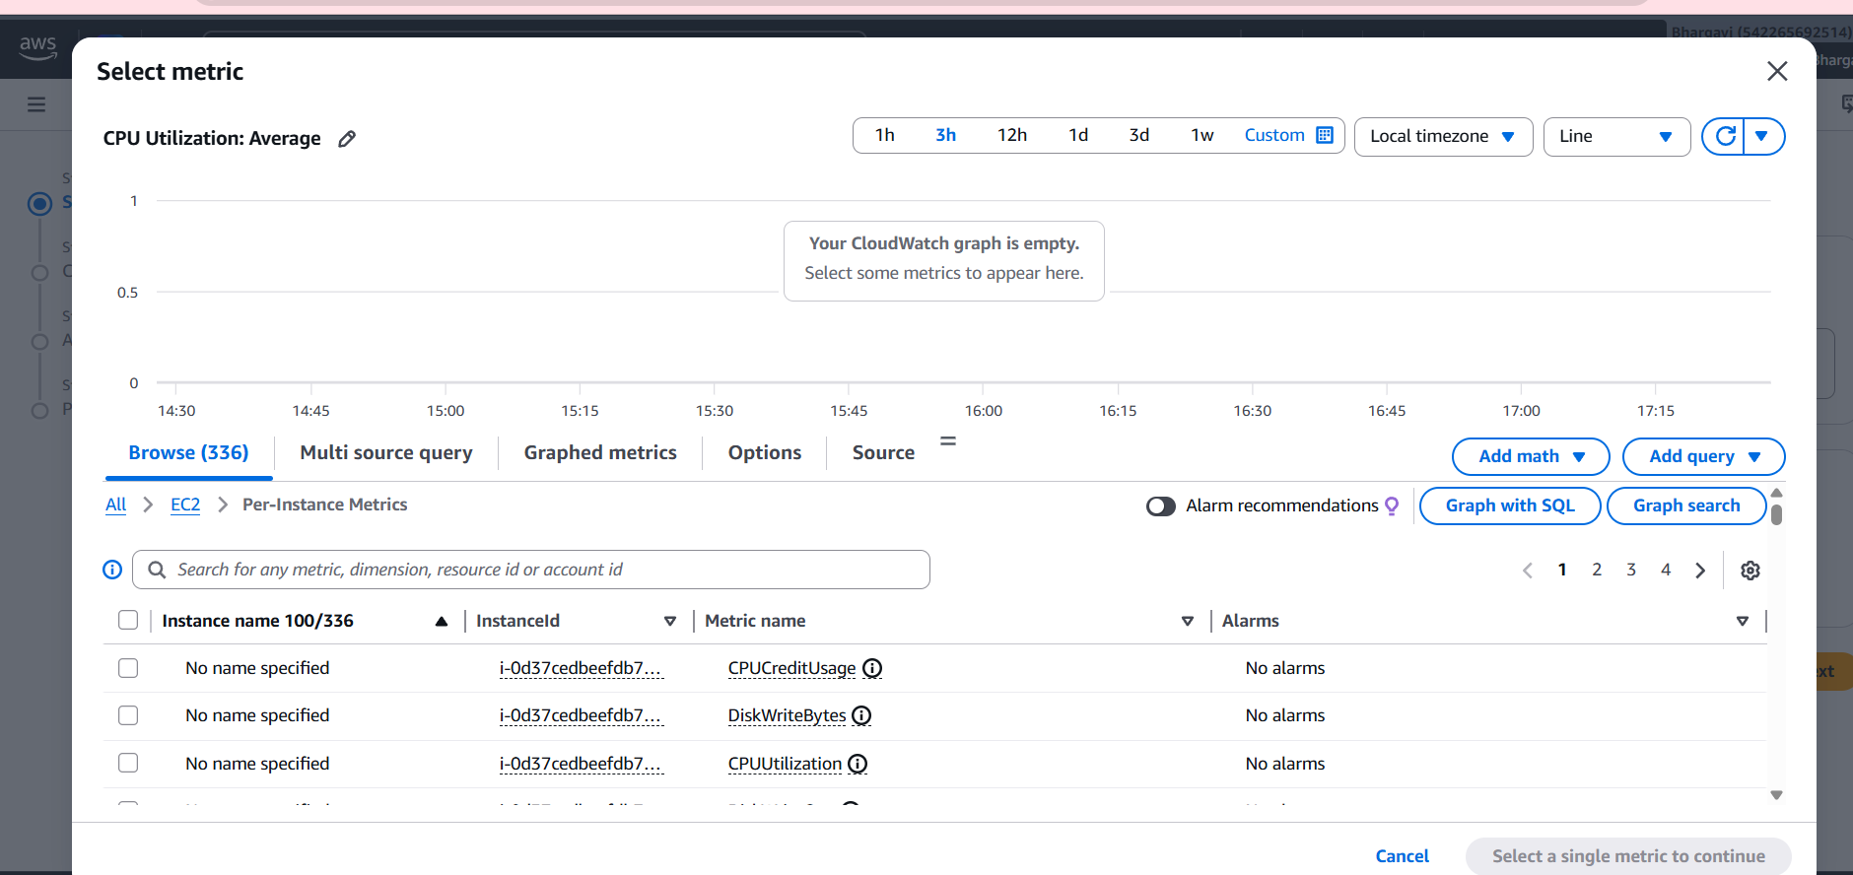
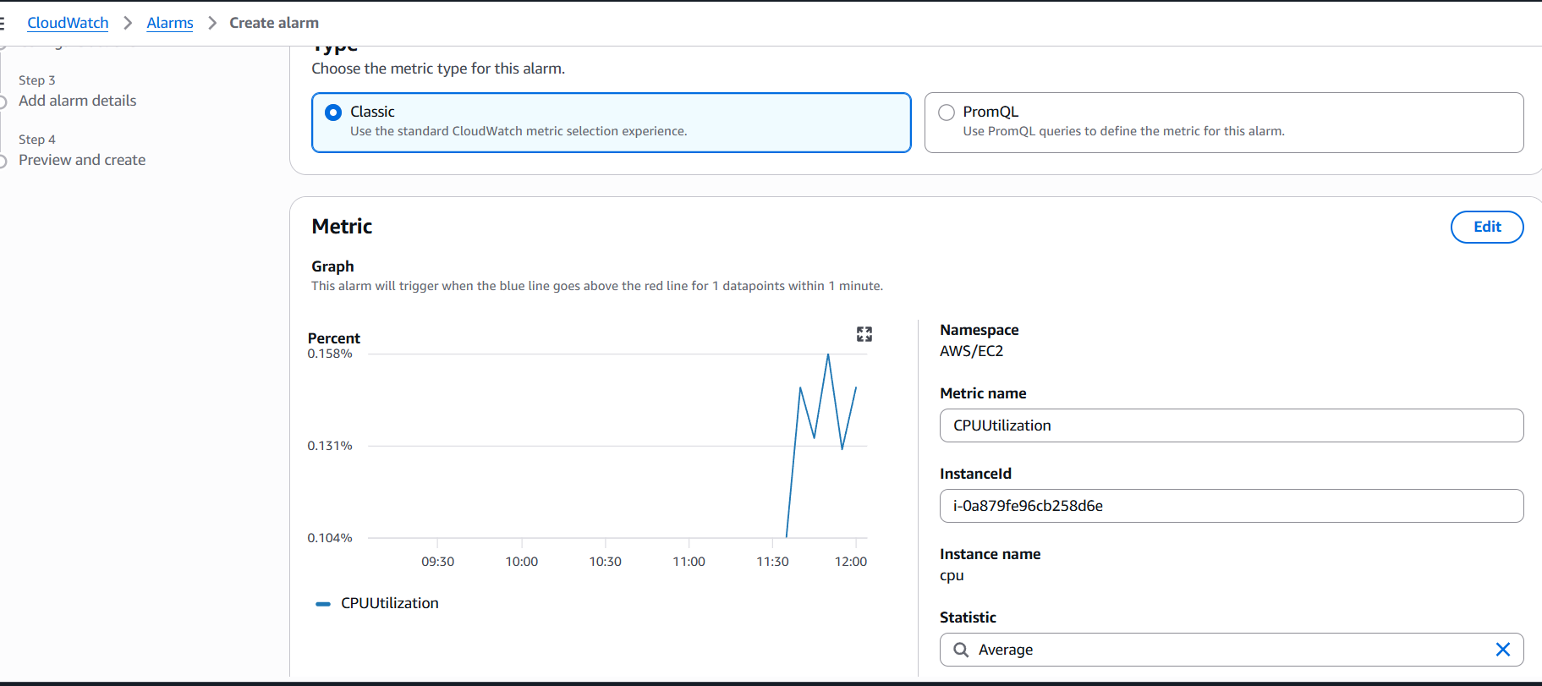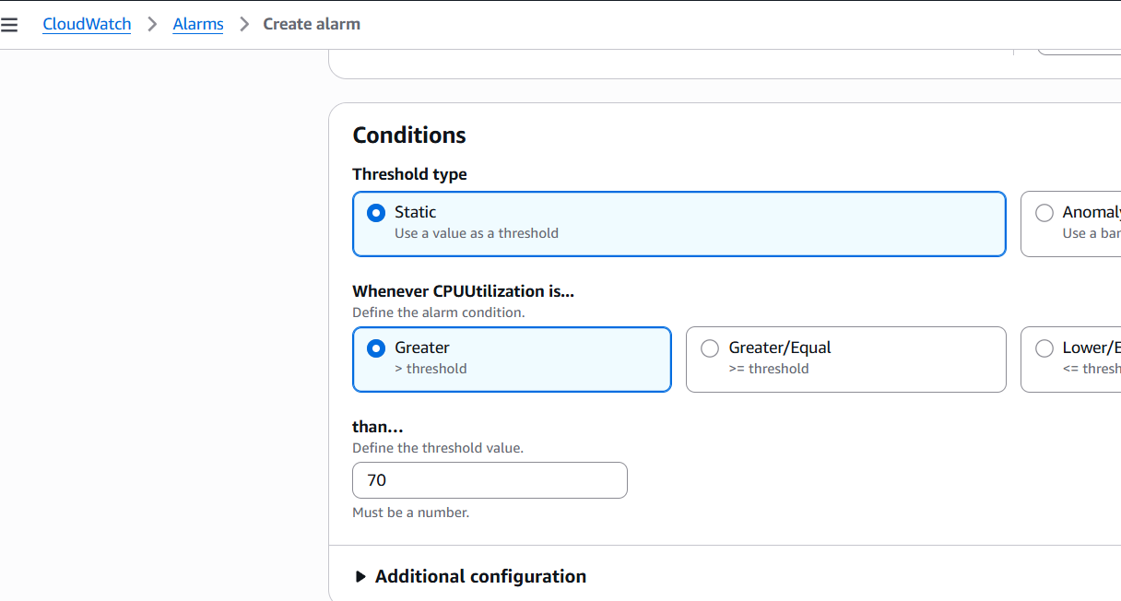
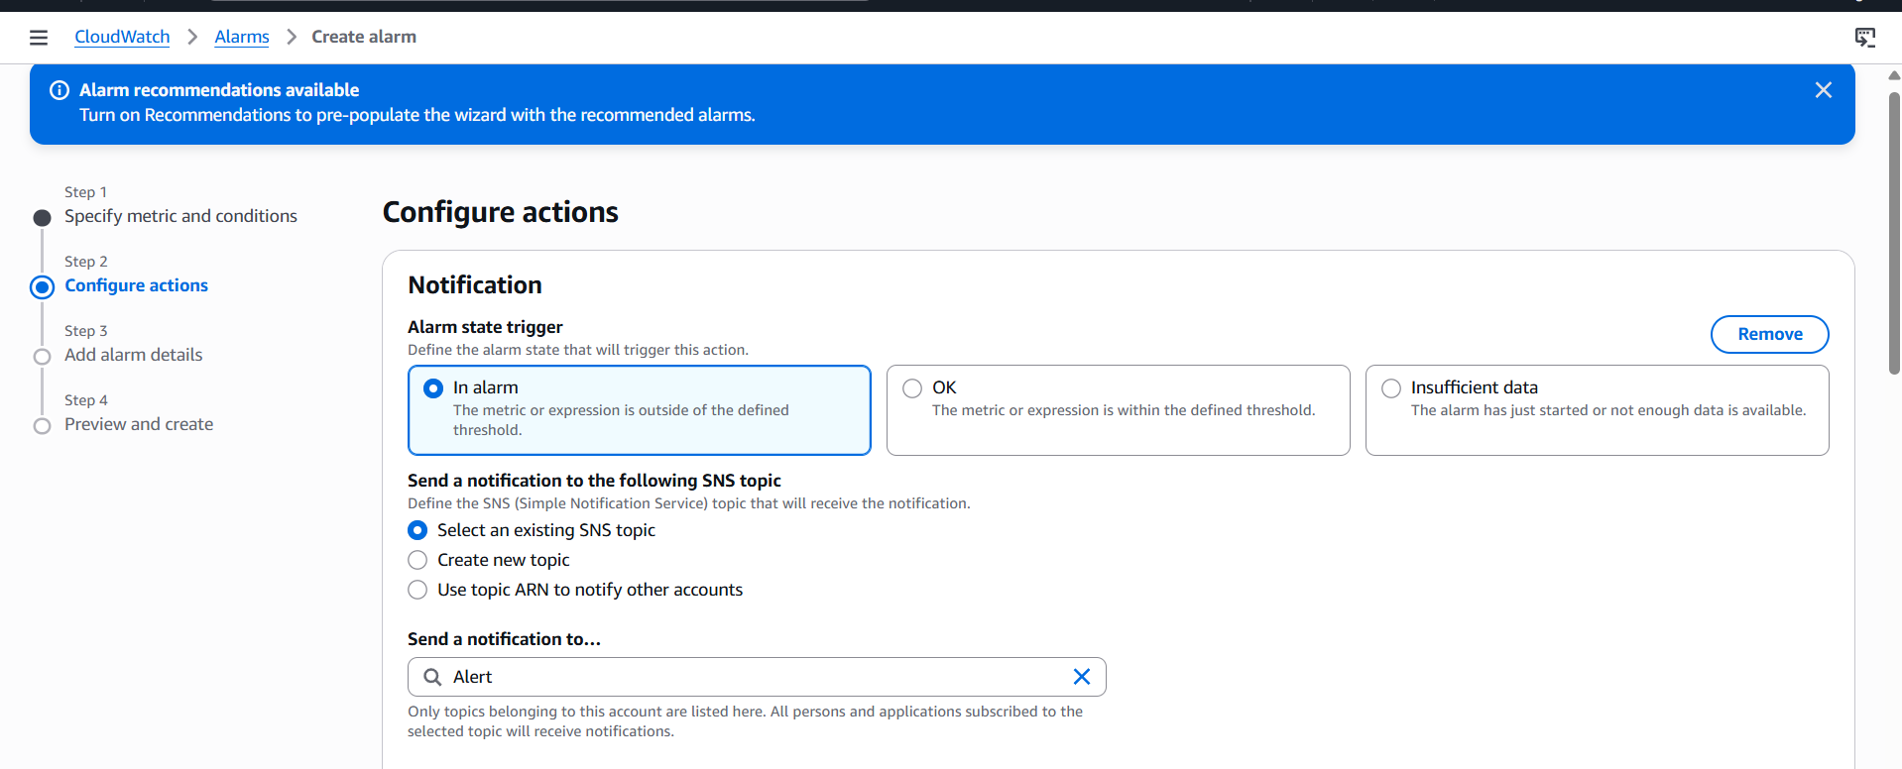
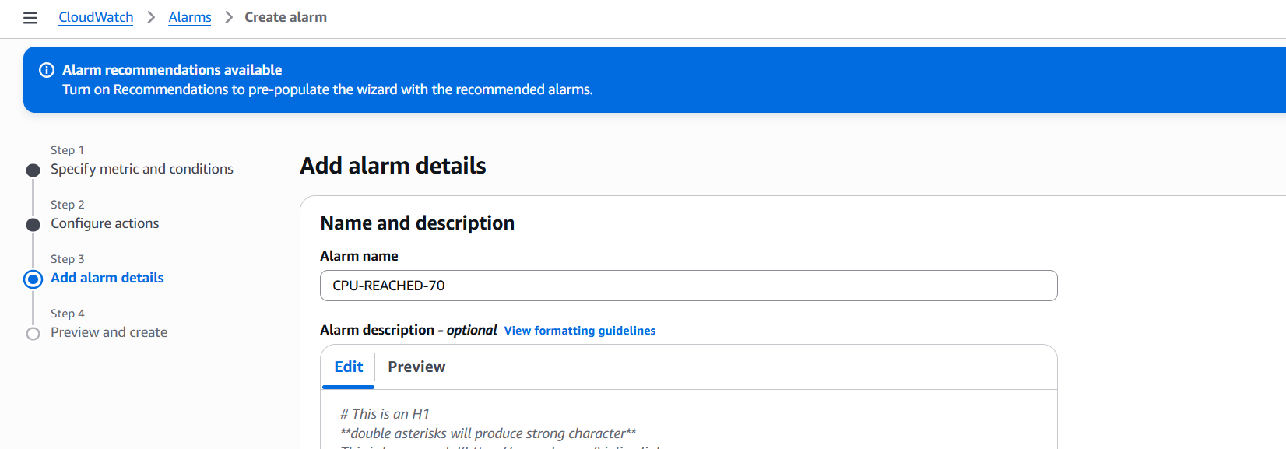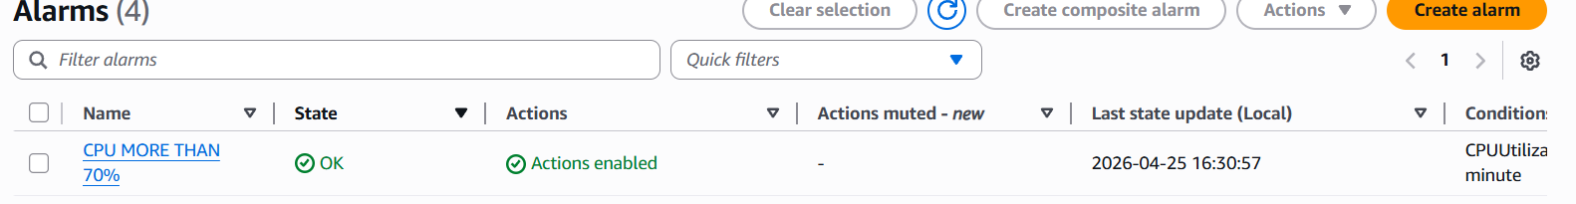
top command will get 0% we use this command will get highing the cpu utilization
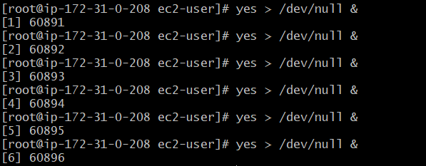
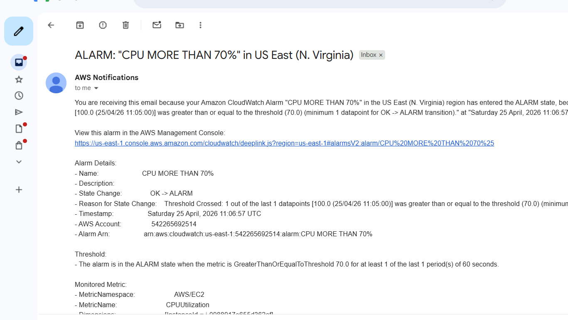

5.Create a Dashboard and monitor the Tomcat service whether it is running or not and send the alert.
New instance will be created and runinstalled tomcat apache and run itcreate an alarm for tomcatFor alarm check in metric and value given low and attached to SNS
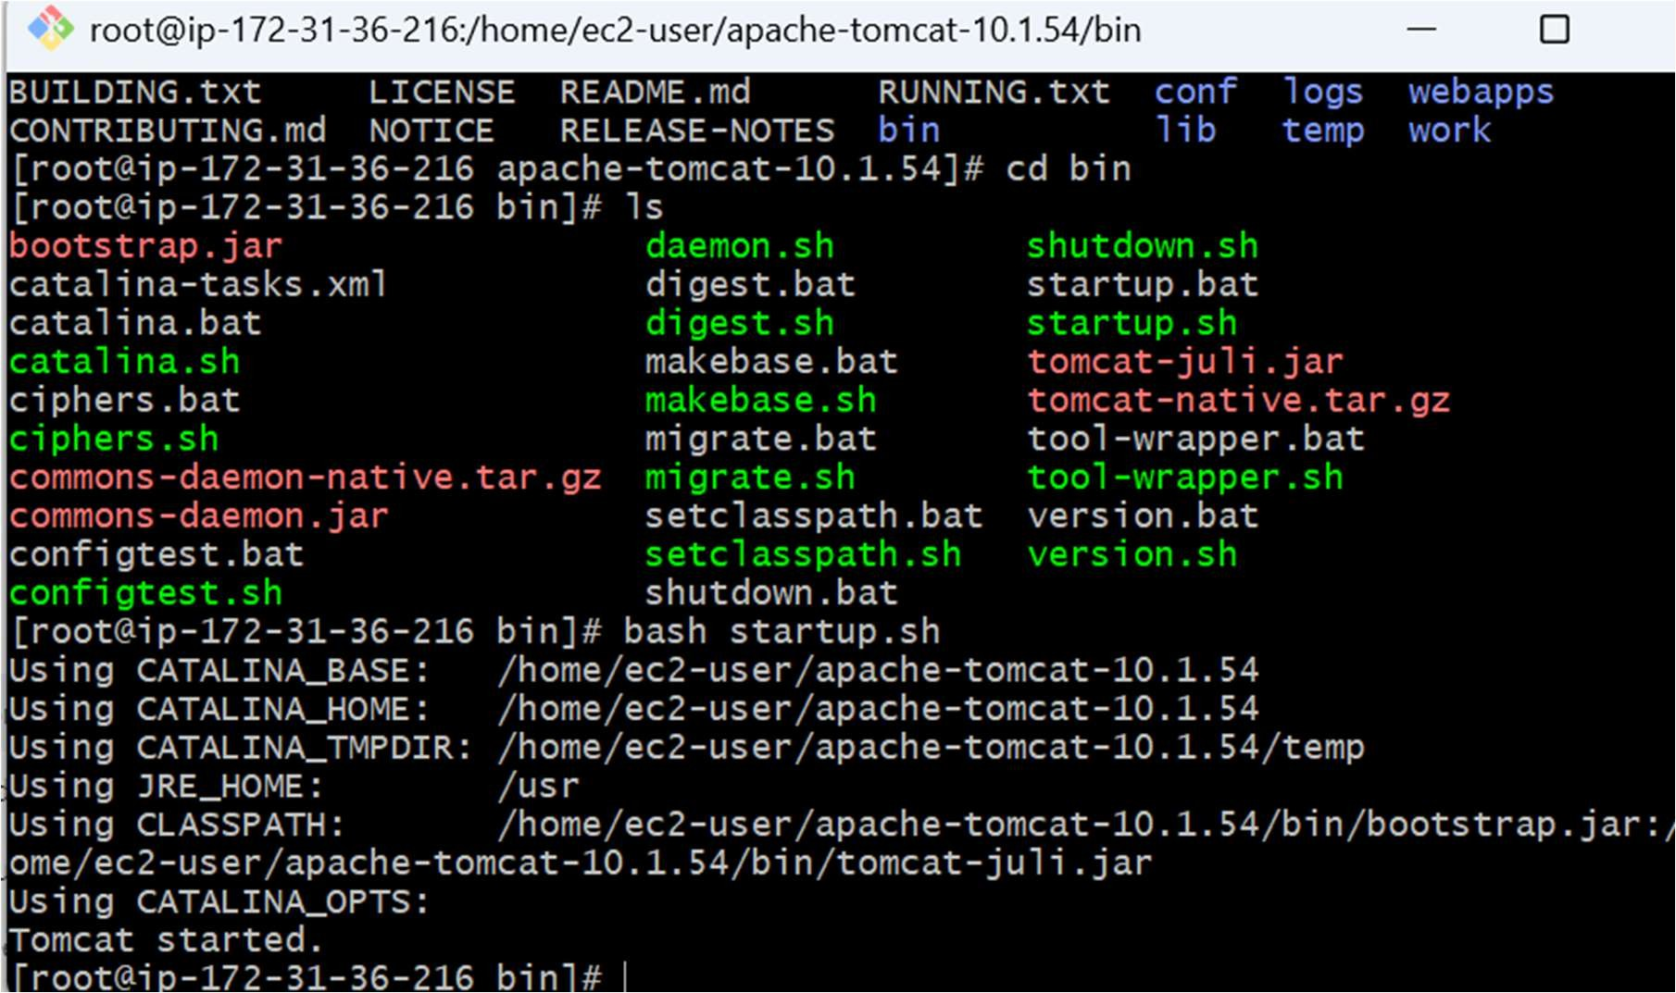
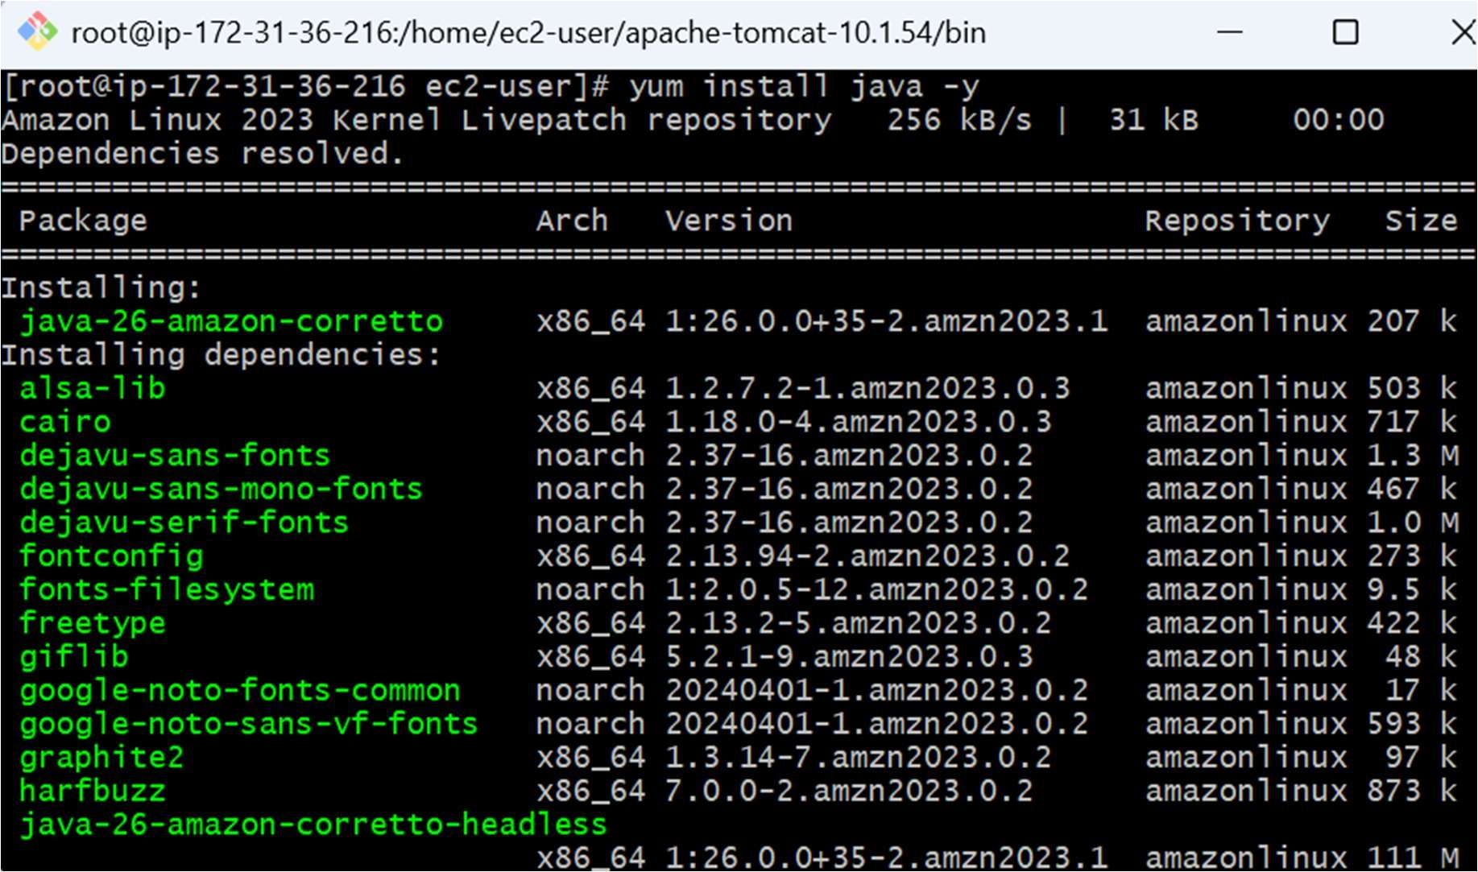
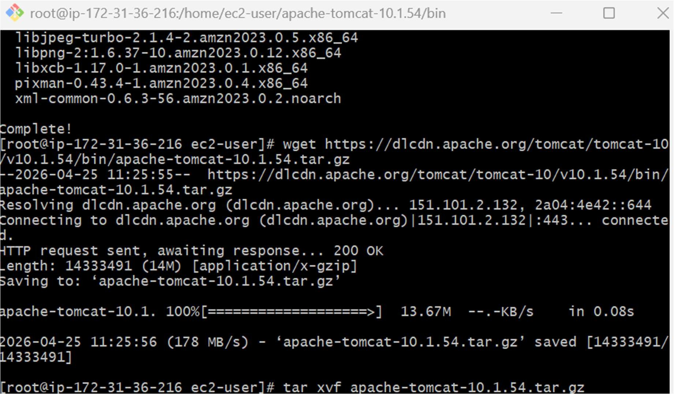
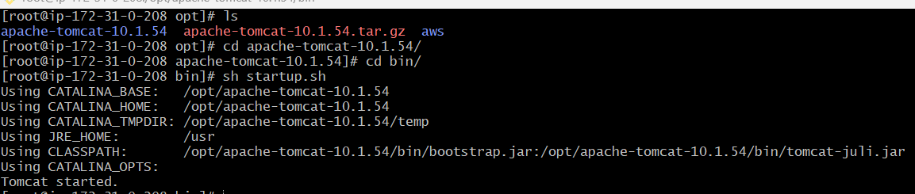

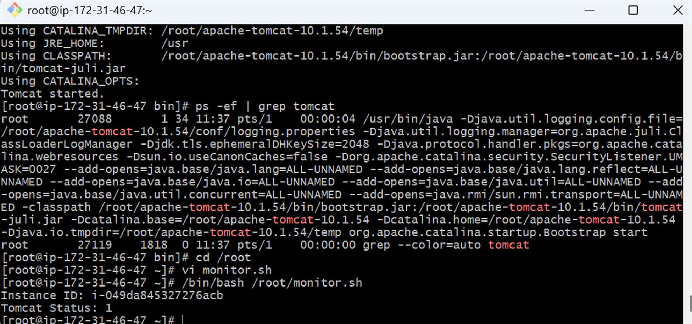
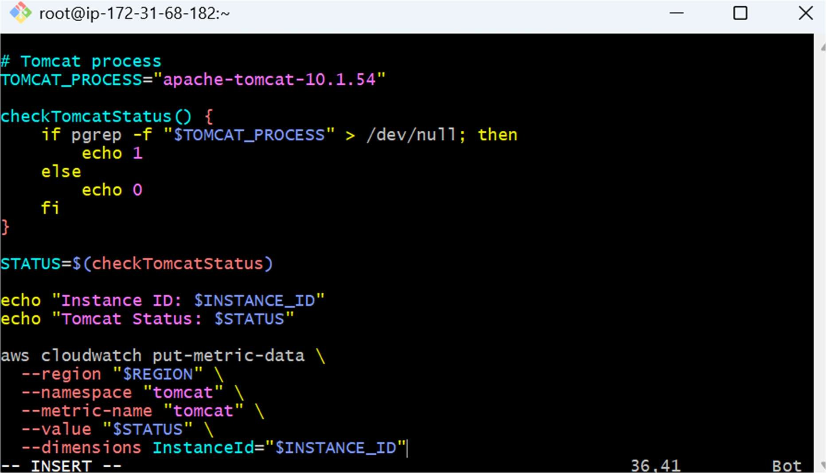
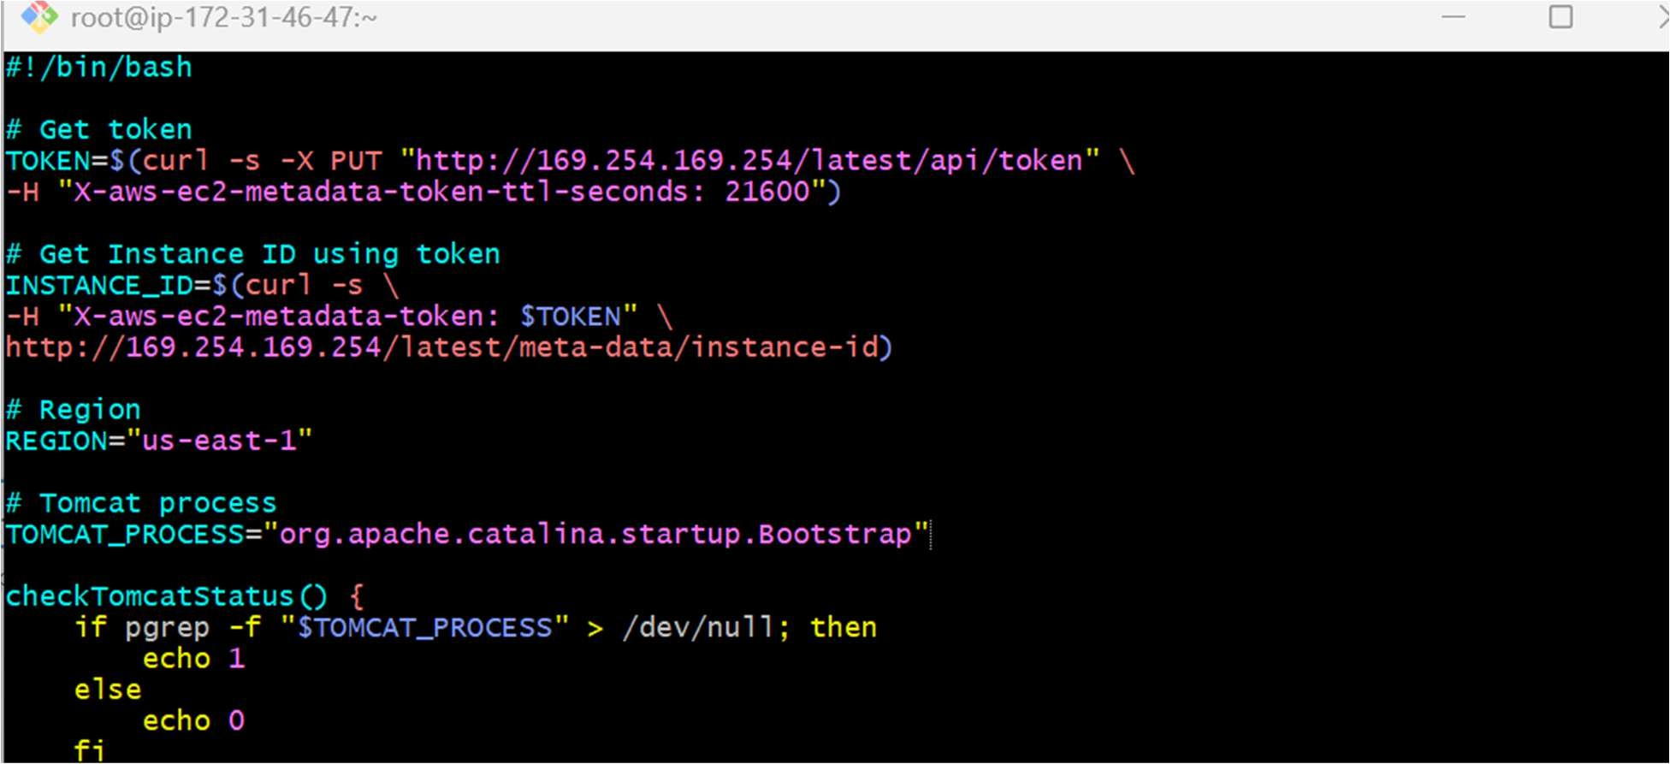

Verify Custom Metric in CloudWatch
Go to AWS Console → AWS Console → Cloudwatch → Metrics → All metrics → Custom namespaces → click on tomcat
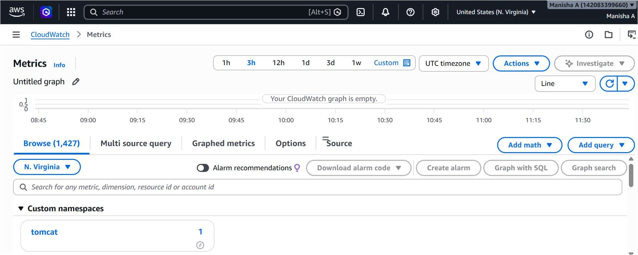
Now lets open it and confirm the test value
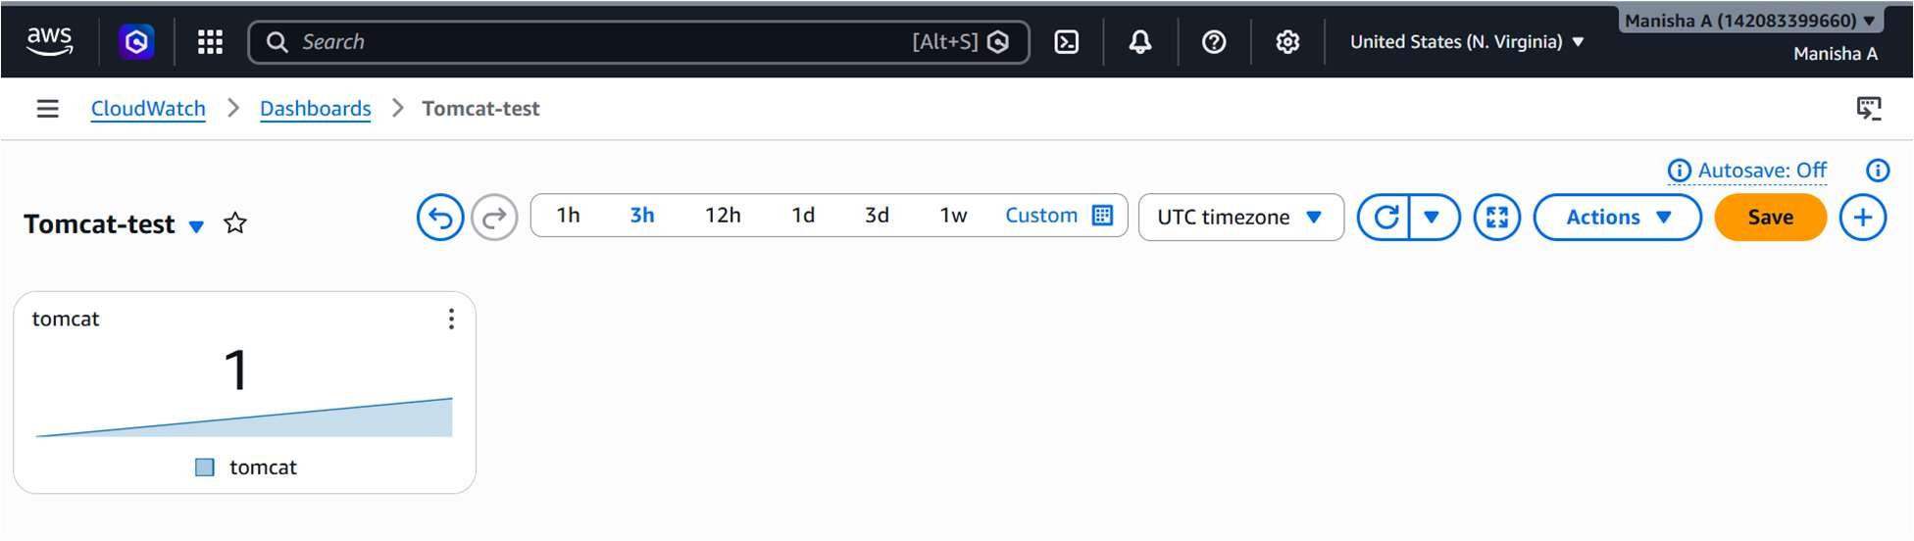
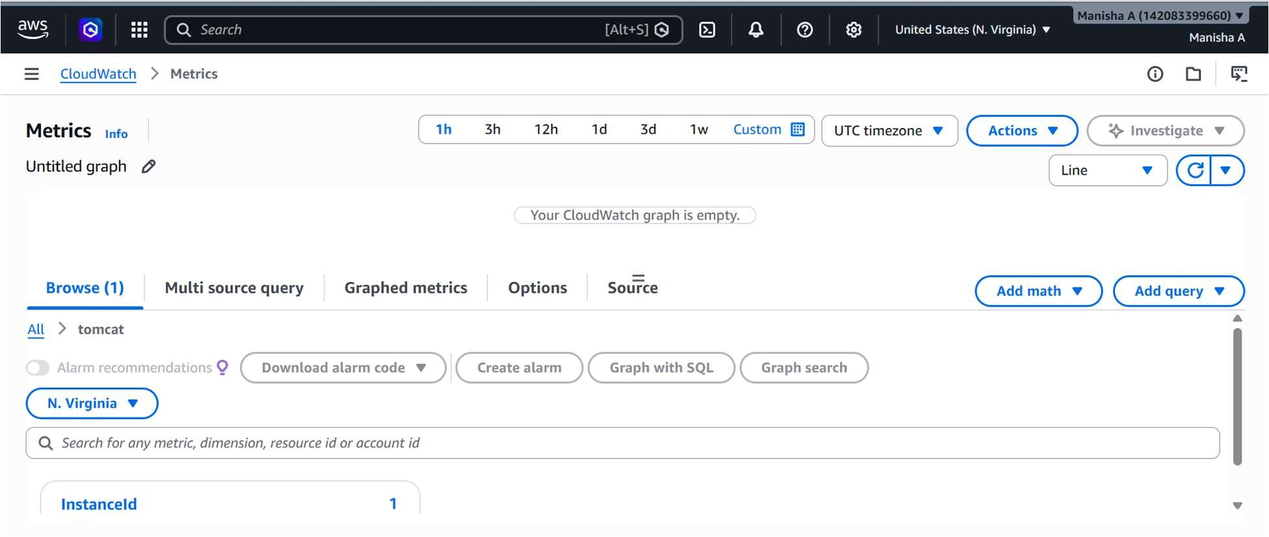
Create CloudWatch Alarm (Tomcat Down Alert)
Go to Alarms → Create Alarm → Select metric → Choose Custom Namespaces →
tomcat
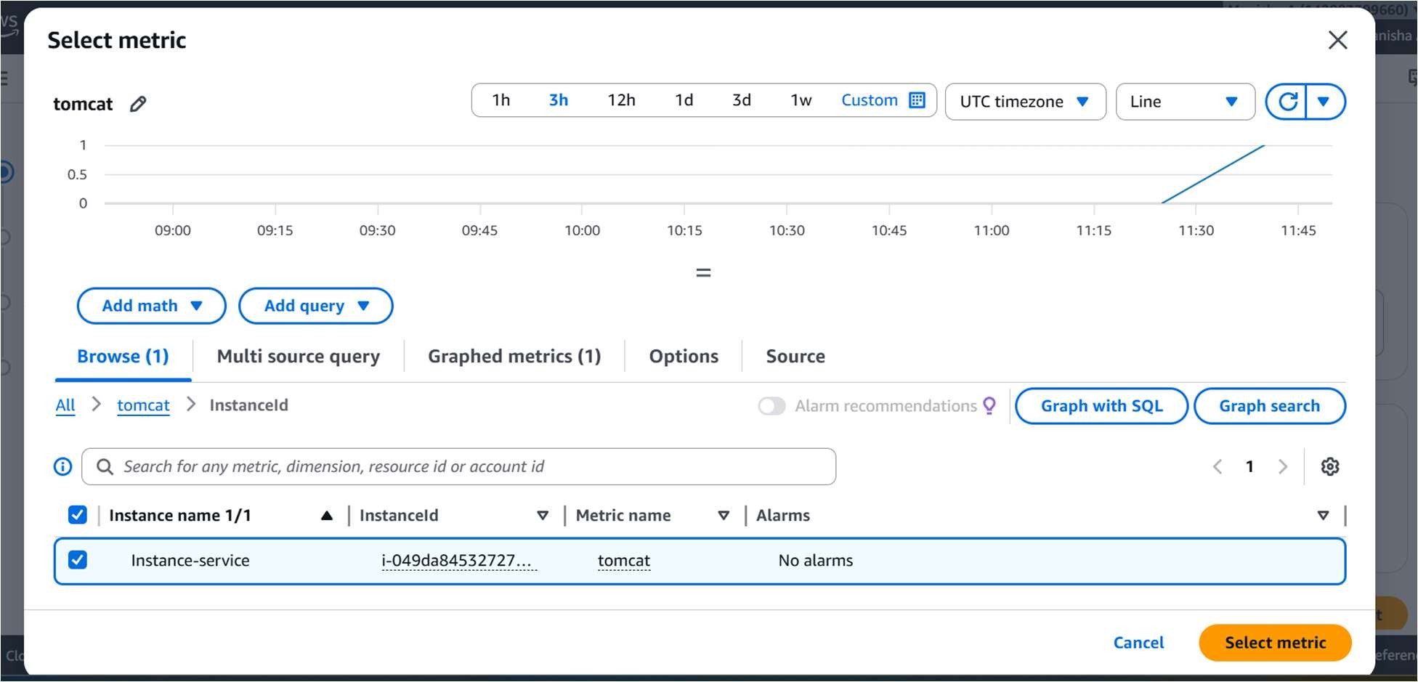

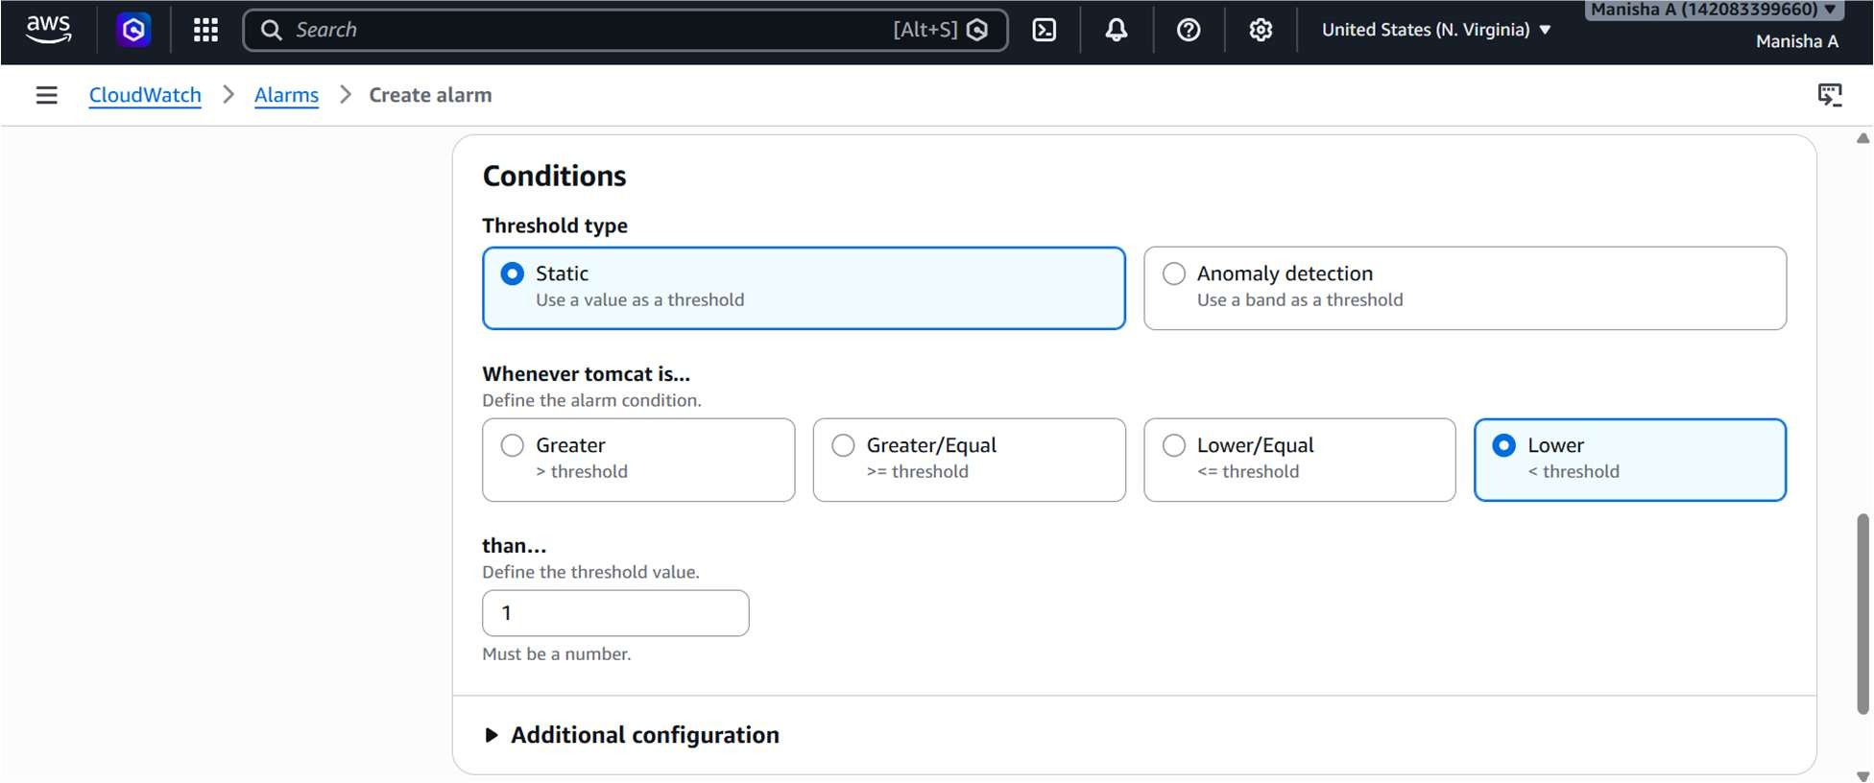

Attach SNS Email Notification
In Notifications:
- Select In alarm
- Choose SNS topic: tomcat-alert-topic
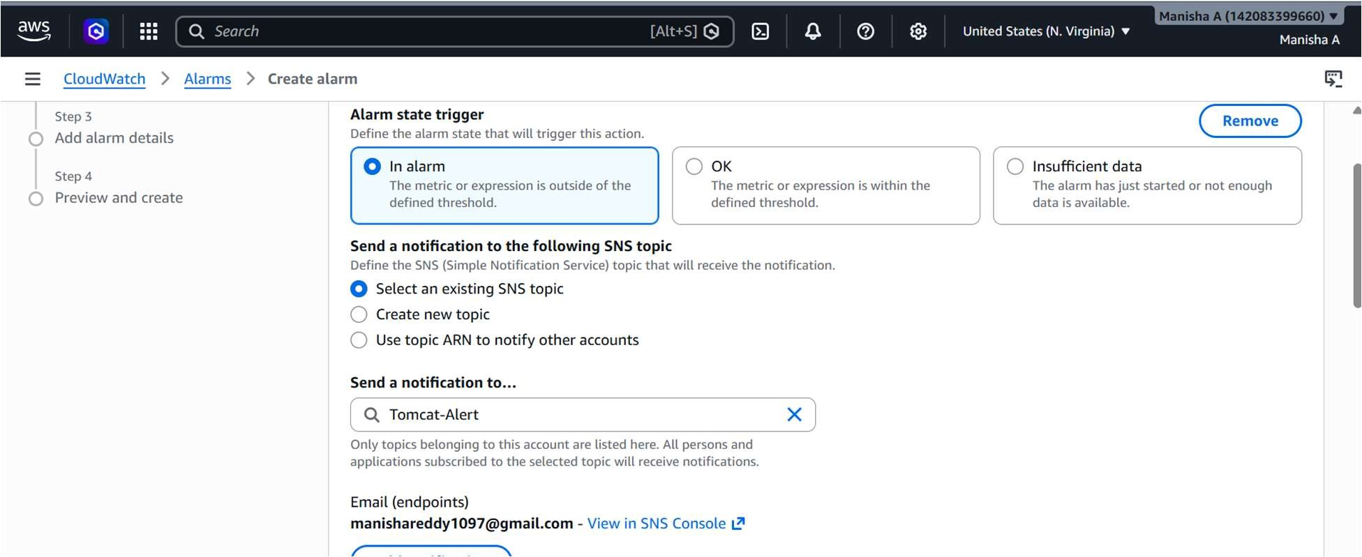

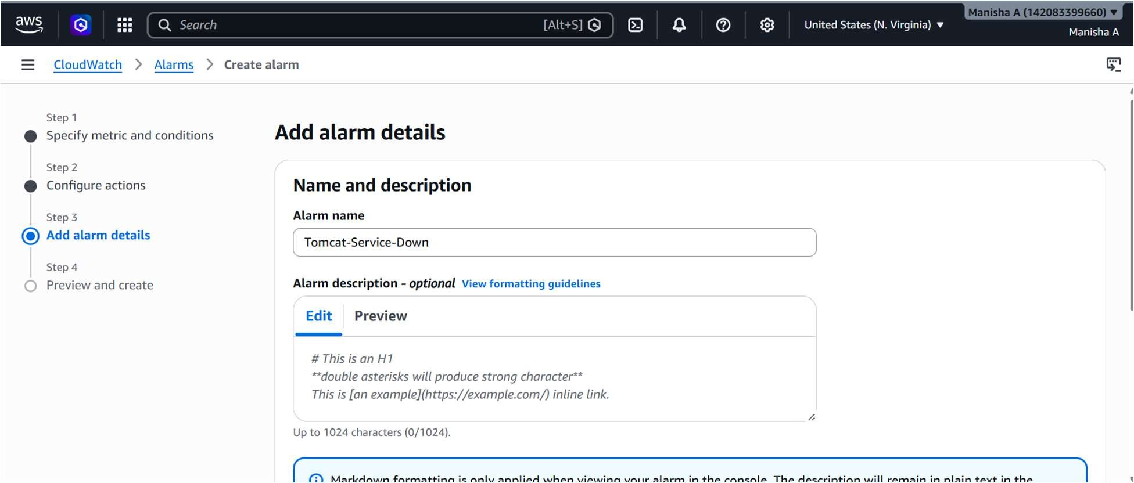
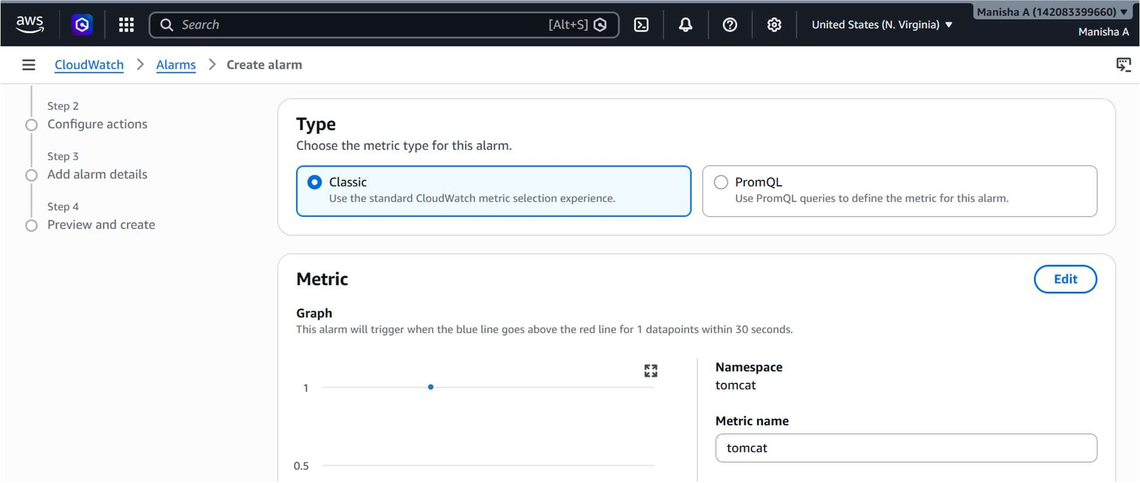

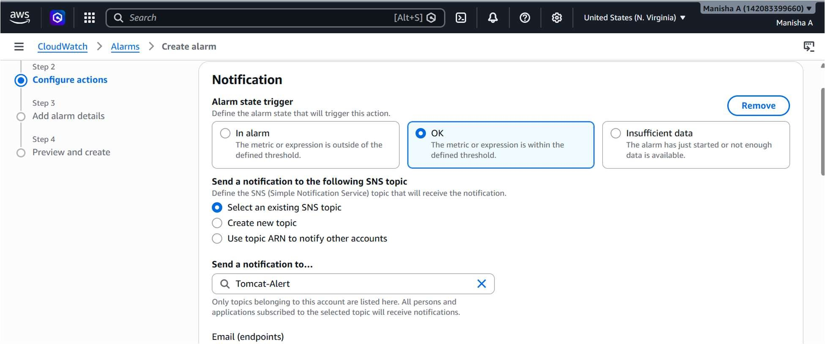
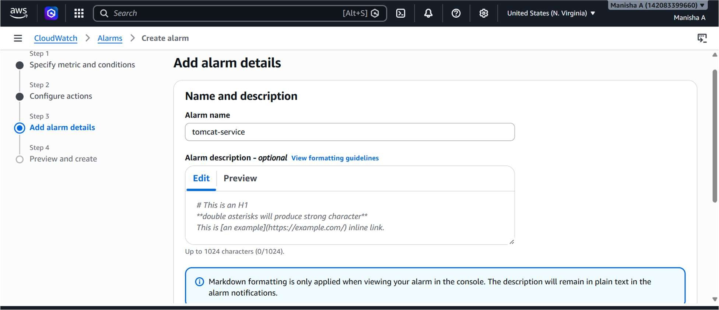
Created a dashboard
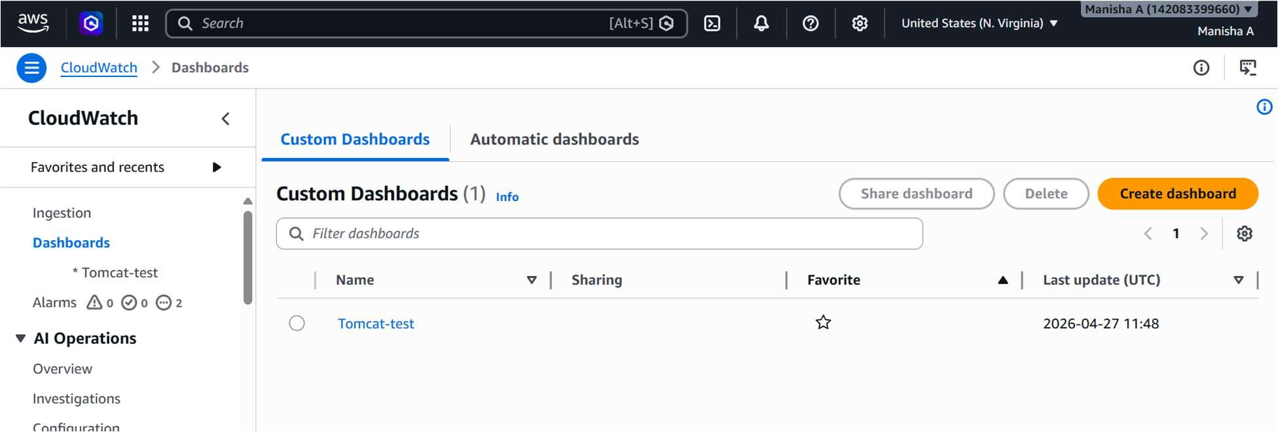
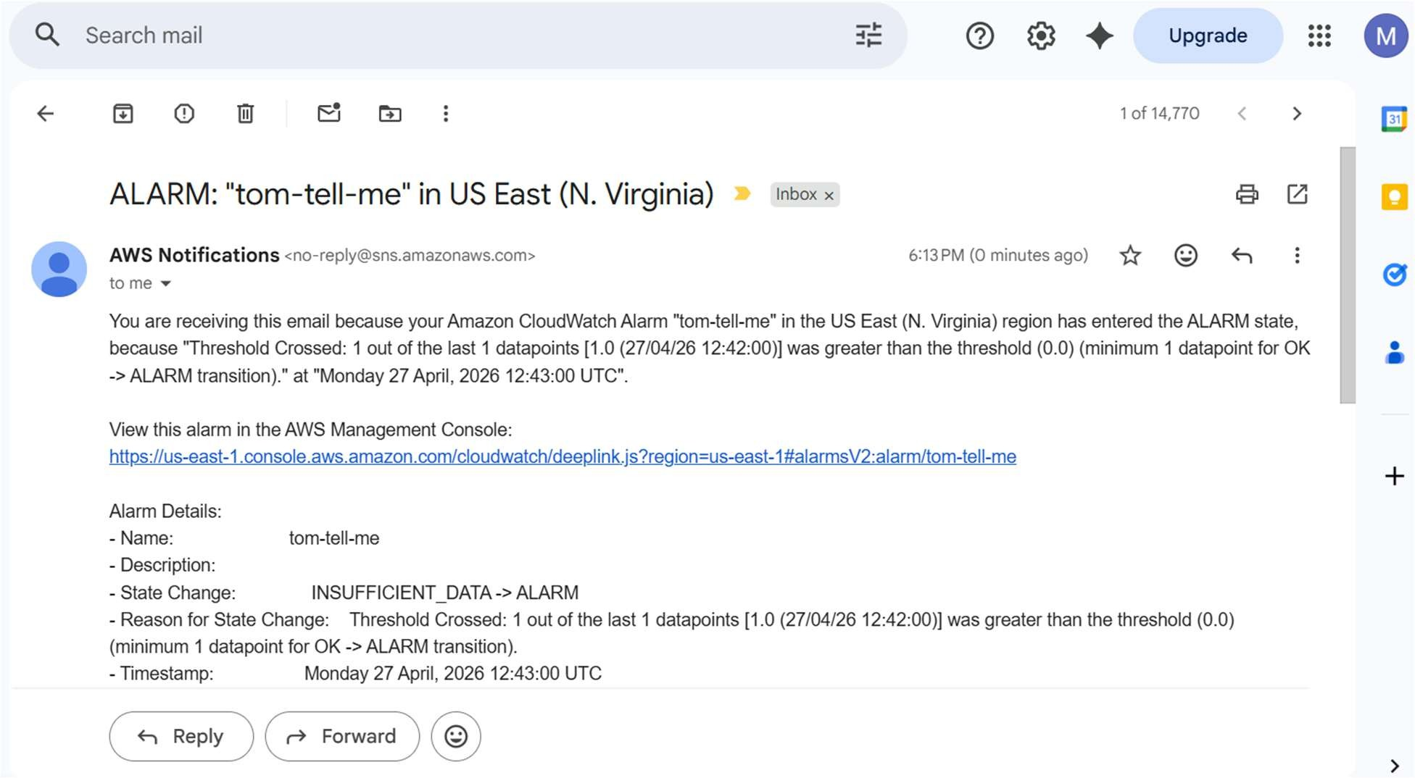

6.Create a Dashboard and monitor the Nginx service to send the alert if Nginx is not running.
-Install nginx
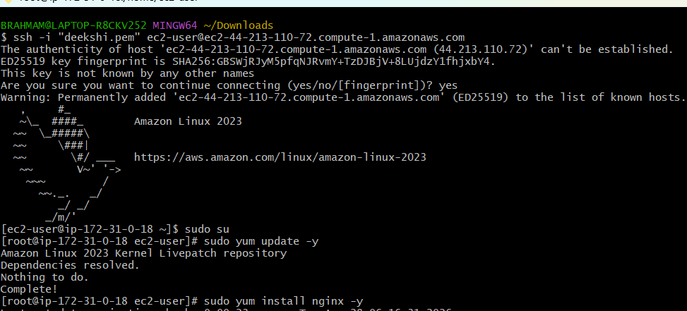
Create a Bash monitoring script on the EC2 instance to check whether the Nginx service is running
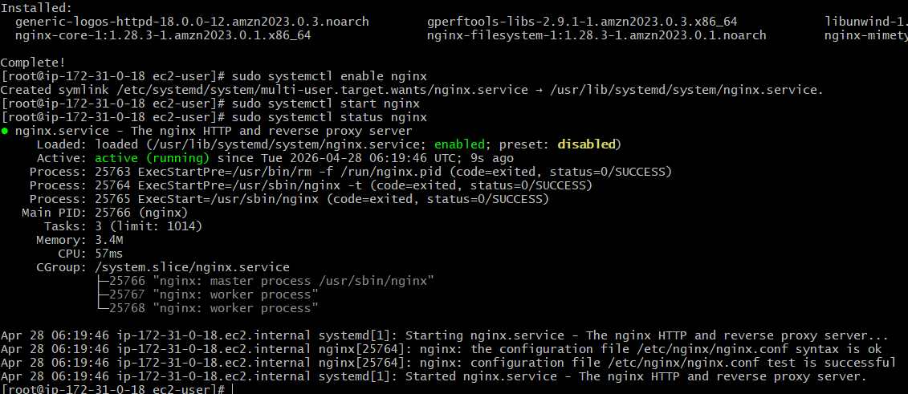
Exit to root user ec2 instsancevi nginx-check.bashopen and write this script
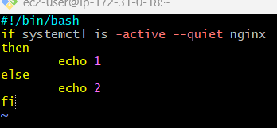
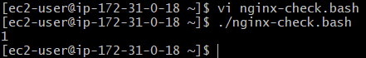
Through aws cli we have to installsudo yum install aws-cli -y
AWS configure
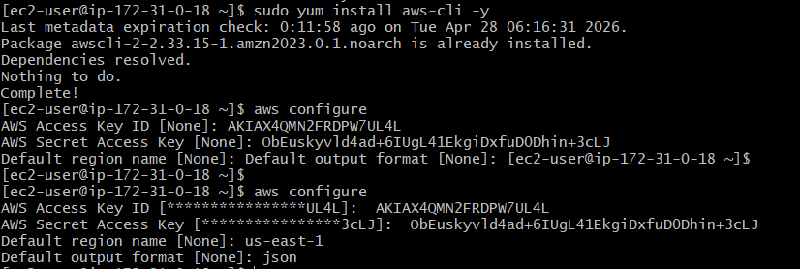
Push metric to cloudwatchverify in cloudwatch
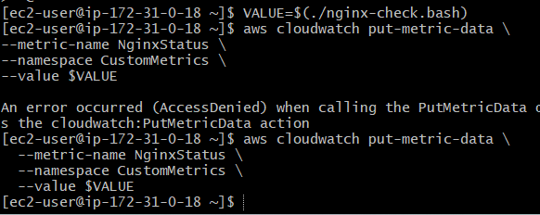
Creating alarm for nginx.service 